**Angular 8(Getting Started)**

What is Angular?

A tool to build interactive websites.

**Benefits**

- Reduction of cost

- Standards Compliance

* ES6
* Modules
* Internationalization & Accessibility

- Performance

- Open Source

- Documentation

Other benefits

* Router, http, forms, rxjs, etc.
* Less Decisions

**Features**

* Progressive Web Apps(can work on mobile)
* Lazy Loading(less data to load website)
* Forms
* RXJS(Asynchronous Data)
* Fully Featured Router
* Animations

**Advance Features**

* Server Side Rendering(rendering your first page view on the server, so the server creates the Html and CSS instead of front end)
* Mobile
* Ng Upgrade (migrate to new framework)

**Angular Architecture**

* One Way Data Flow

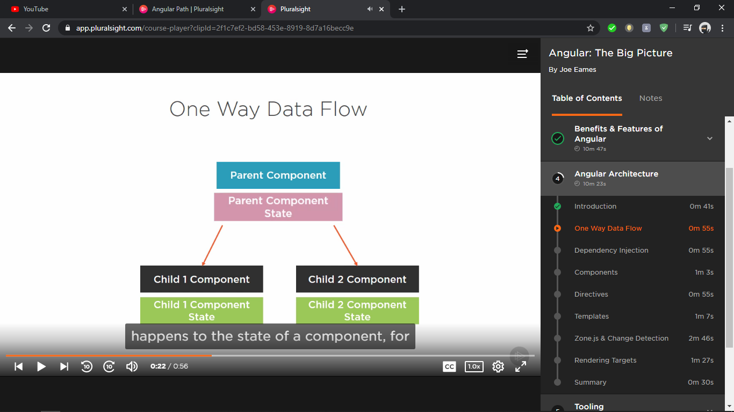

* Dependency Injection
* Components
* Directives
* Templates(templateUrl : ‘./about.component.html’)
* Zone.js

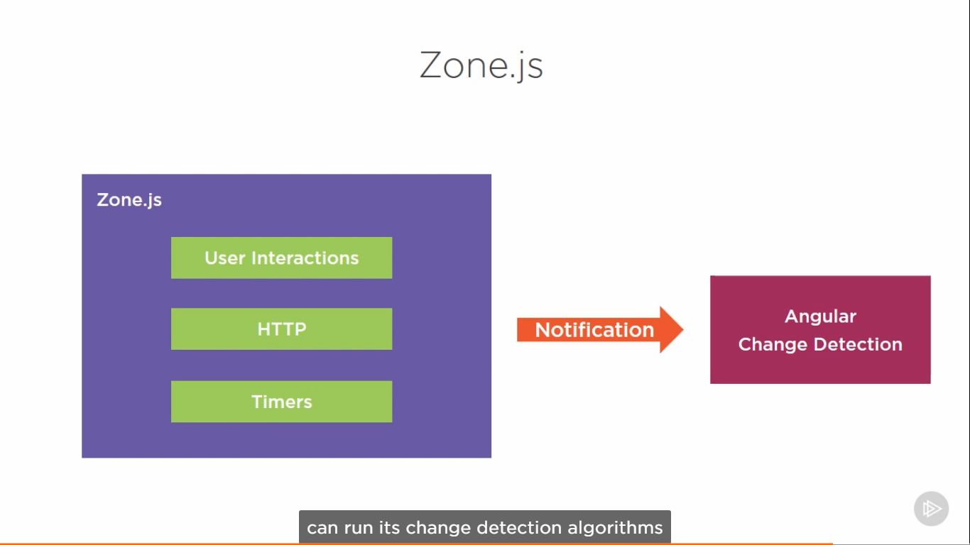

* Multiple Rendering Targets(Mobile, Server side, Desktop Apps)

**Server Side Rendering**

This happens using a tool called Angular Universal.

Benefits

* Performance
* Initial download size
* Render Time
* Search Engine Optimization

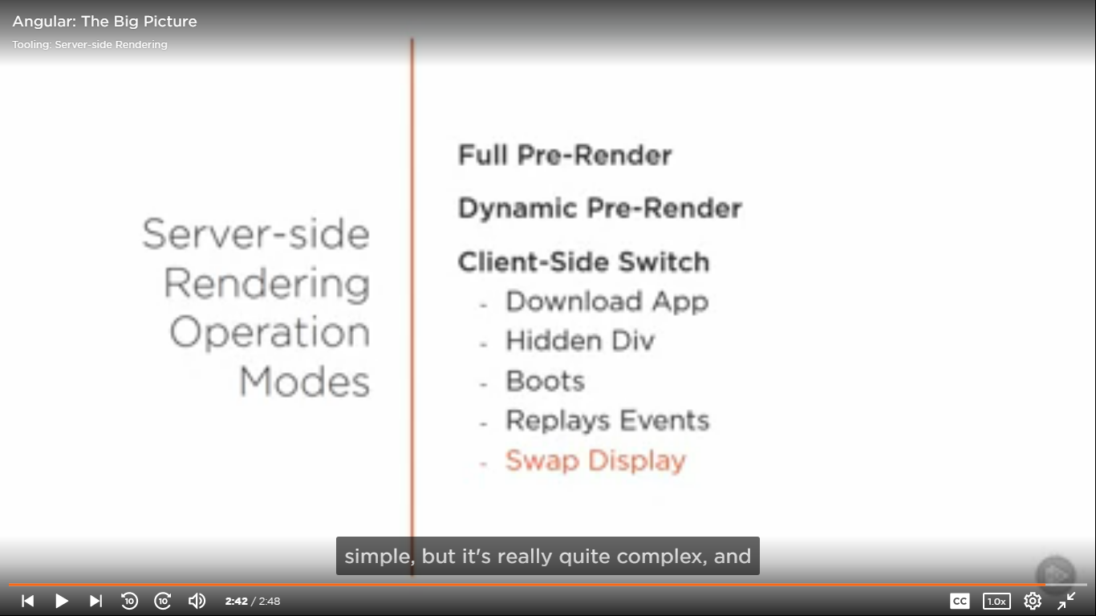

**Mobile Tools**

- Ionic

- NativeScript

**Desktop**

- Electron (Visual studio code was created by this).

**Testing Tools**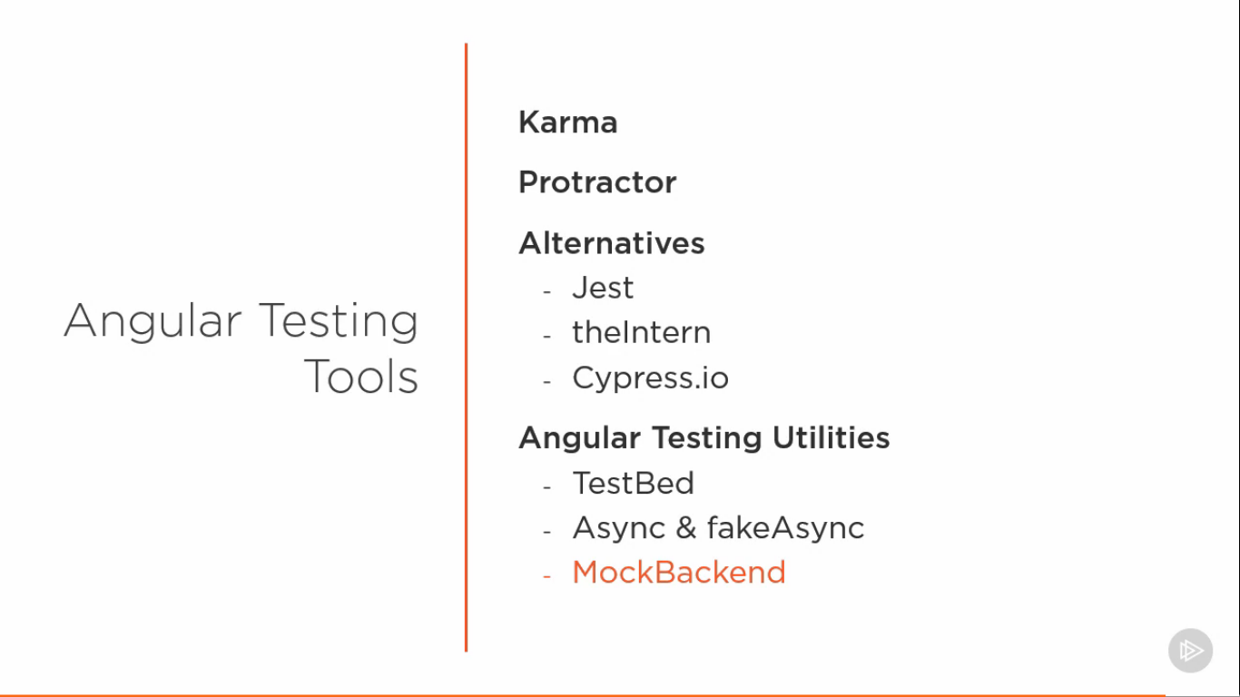

Karma – Unit Testing

Protractor – Web automation testing for entire application

TestBed – Test component with the template

MockBackend – Http calls

**AOT Compiler (Ahead Of Time Compiler)**

The Angular Ahead-of-Time (AOT) compiler converts your Angular HTML and TypeScript code into efficient JavaScript code during the build phase before the browser downloads and runs that code. Compiling your application during the build process provides a faster rendering in the browser.

**Complex Concepts**

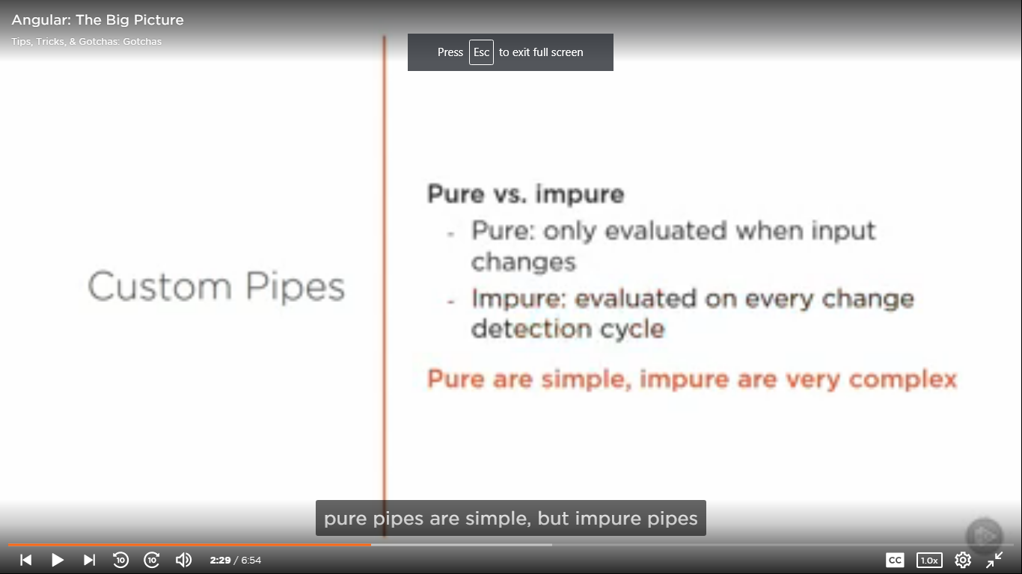

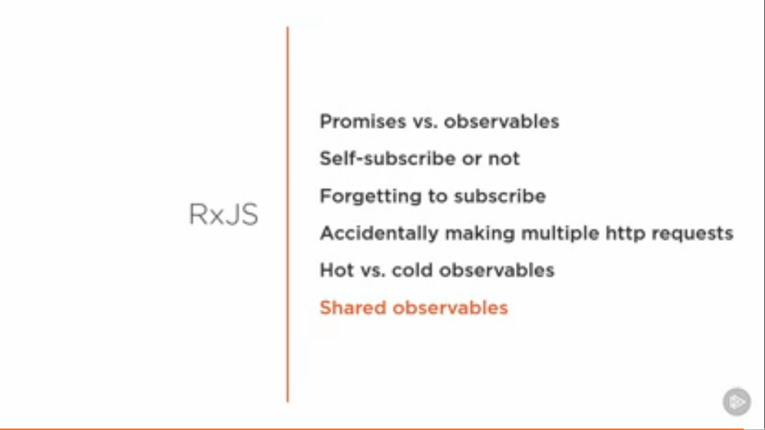

**TIPS**

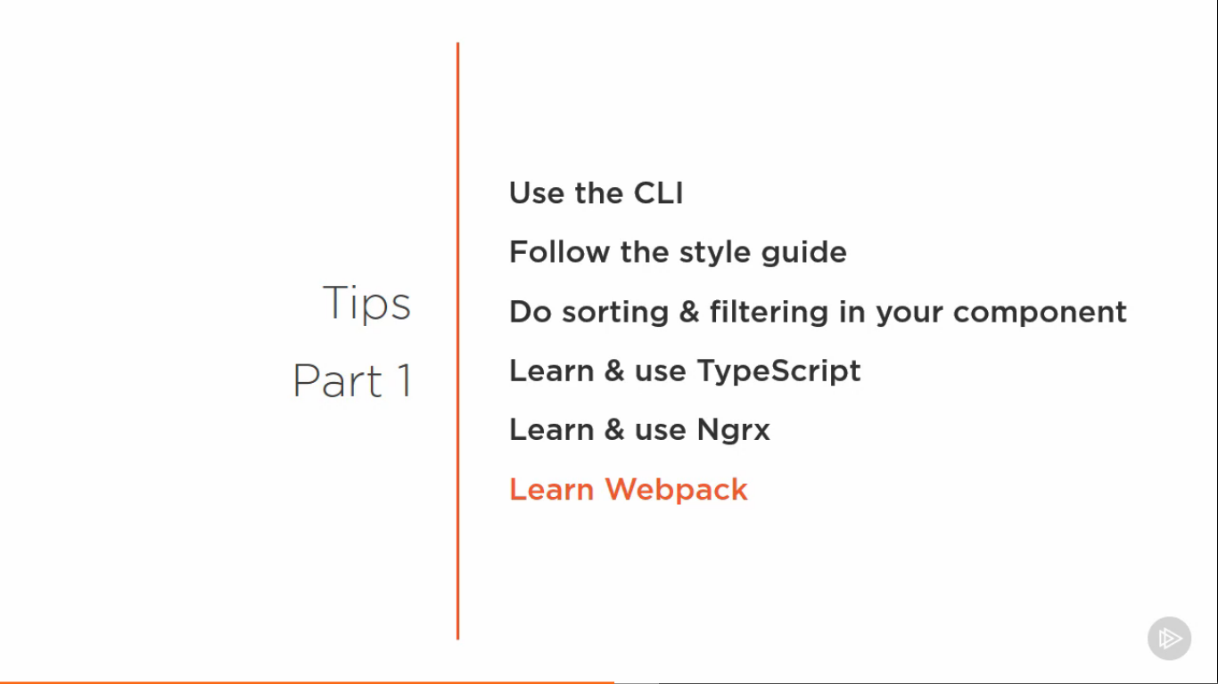

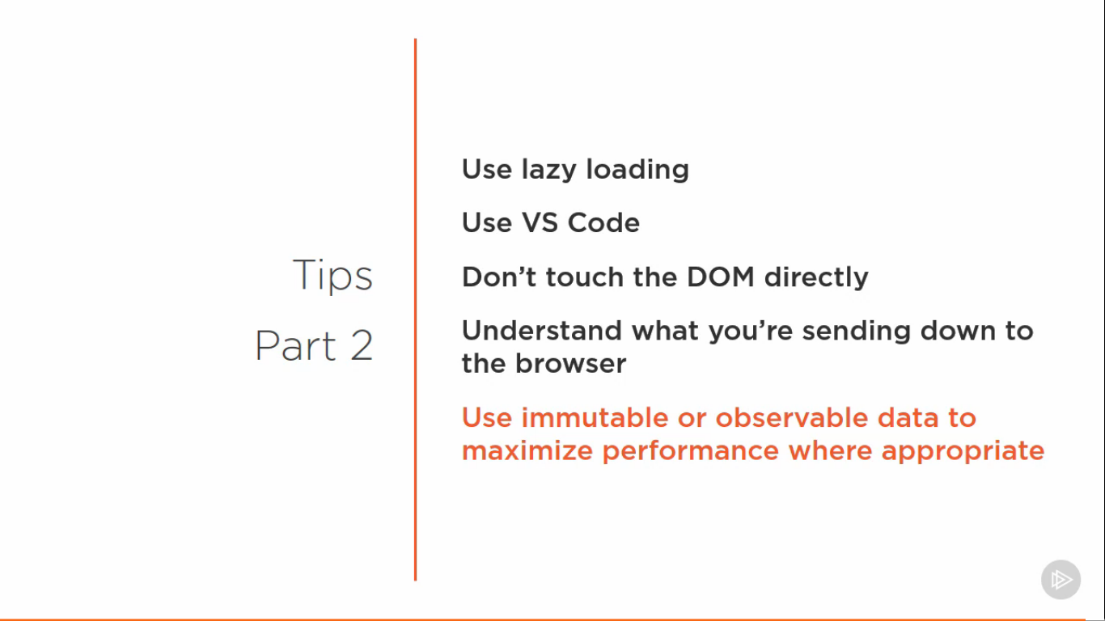

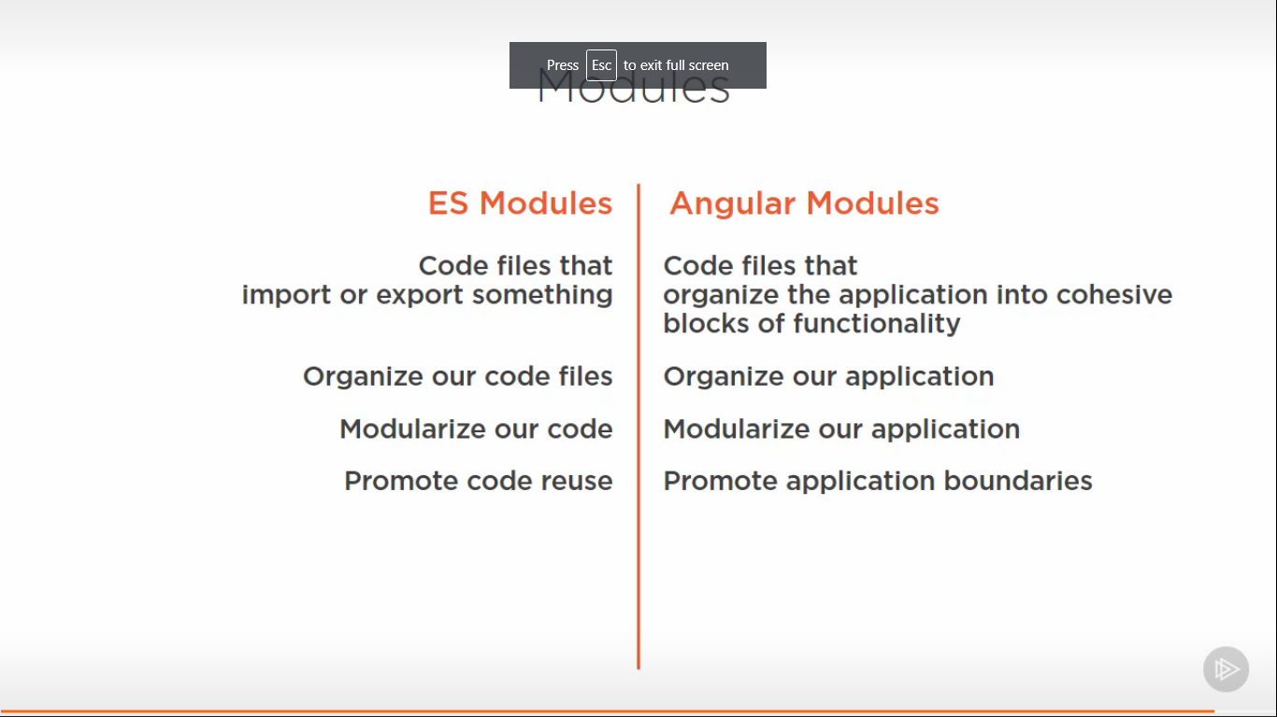

**Component**

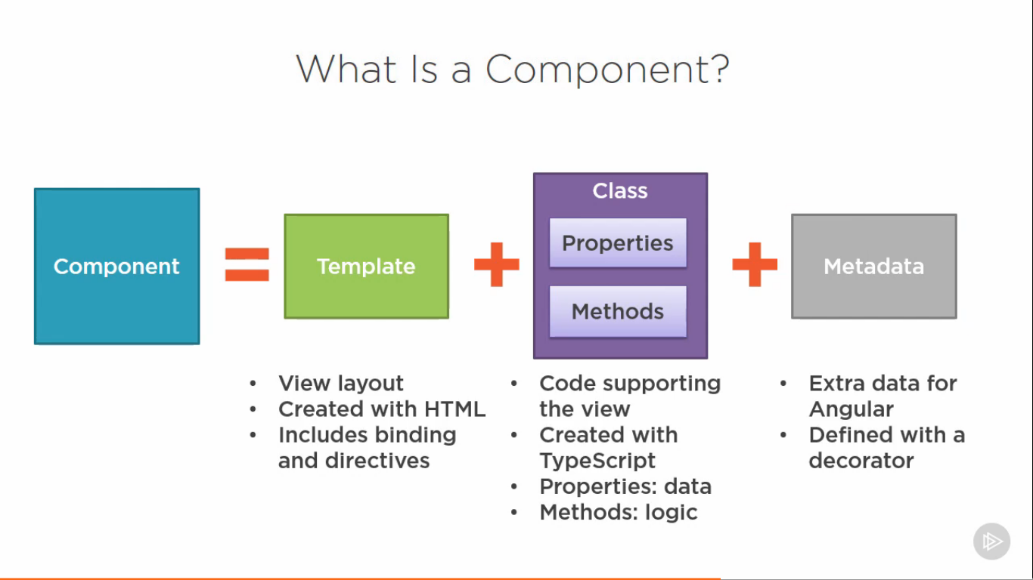

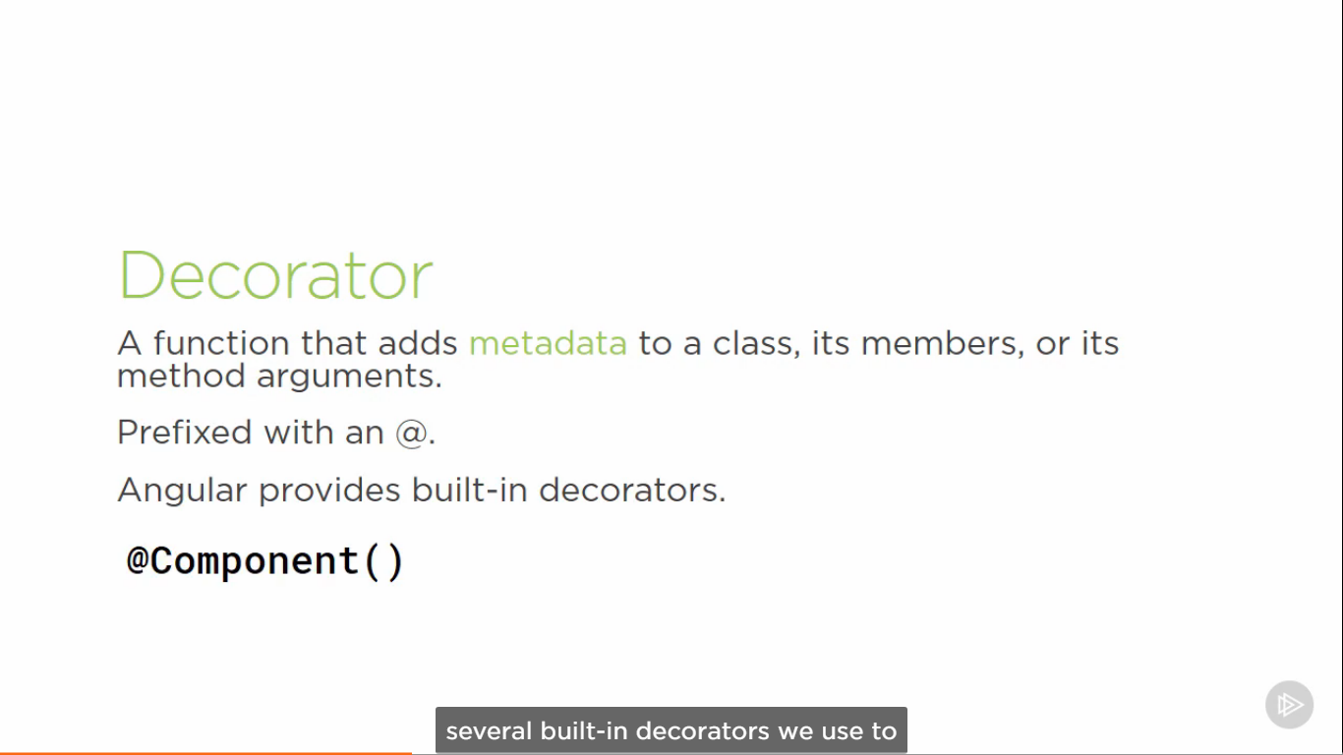

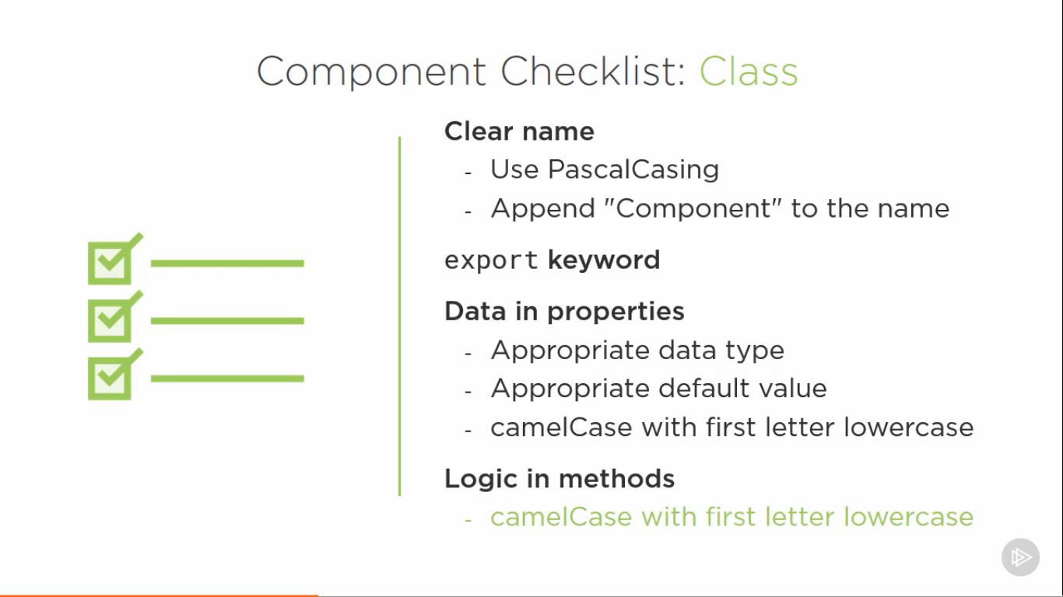

**Data Binding**

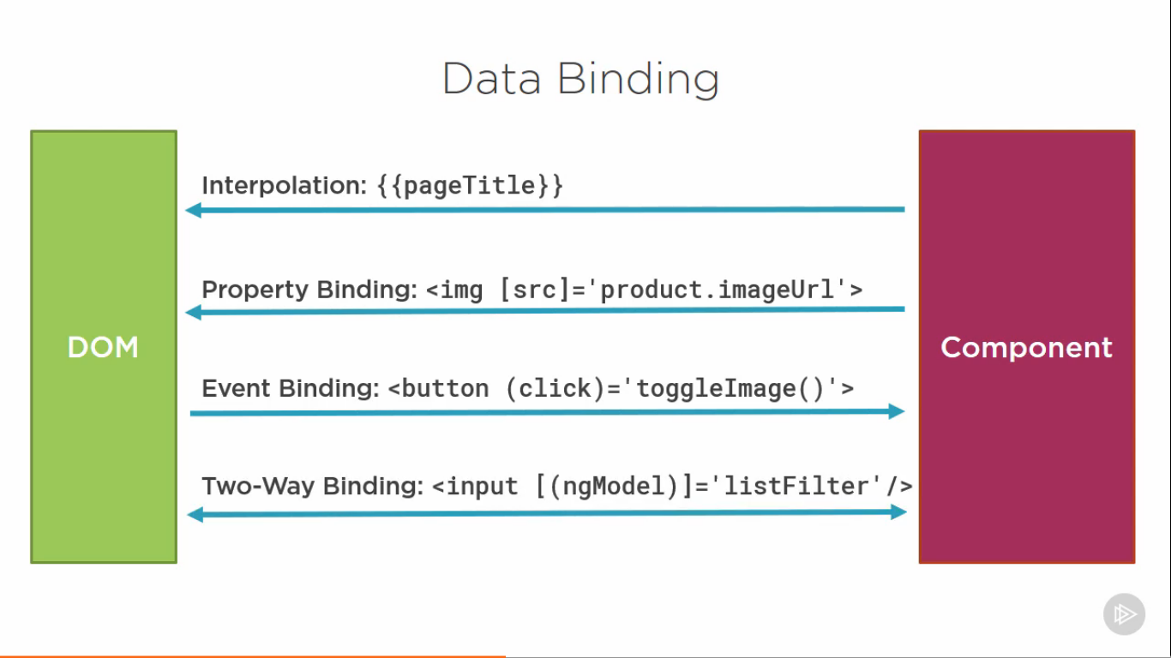

**Component Tips**

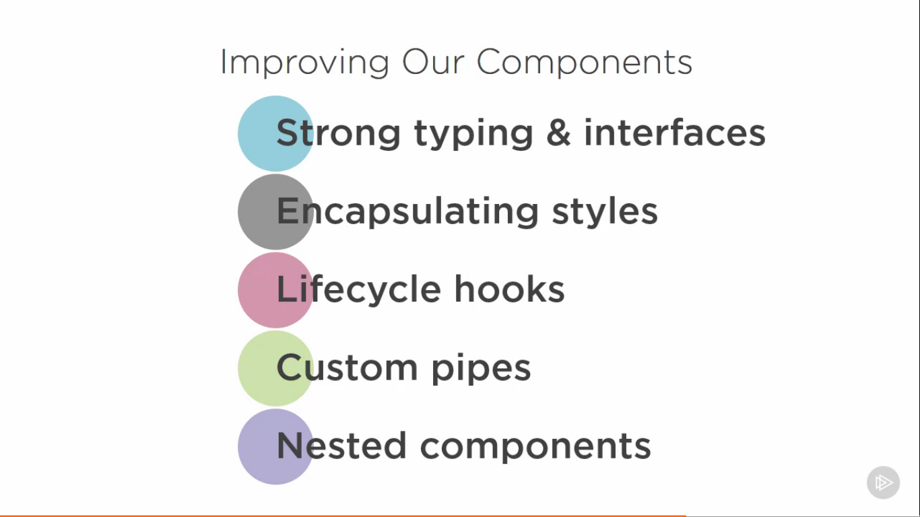

**Lifecycle Hooks**

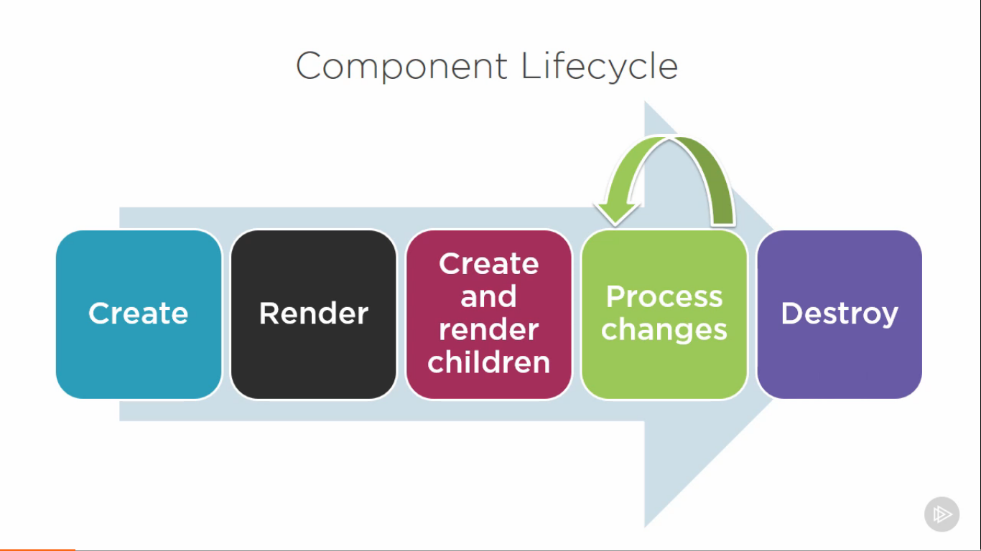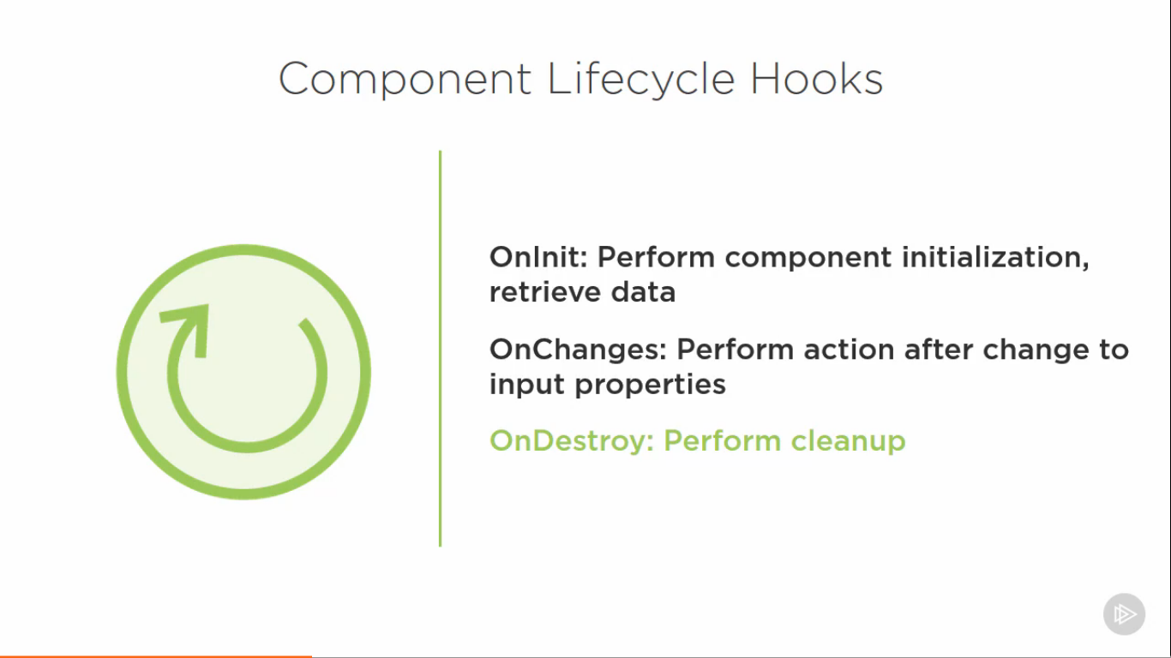

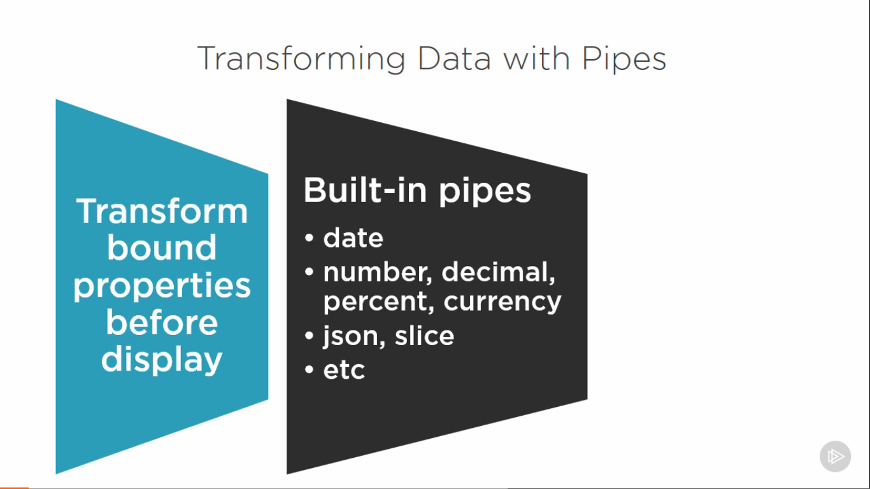

**Passing data from parent to child component (@Input)**

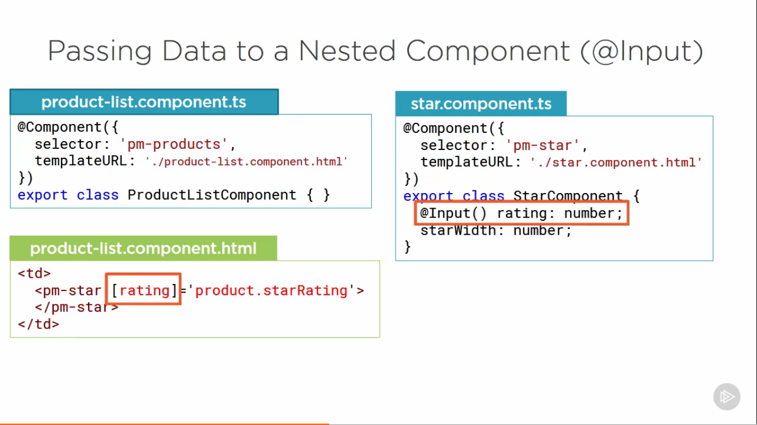

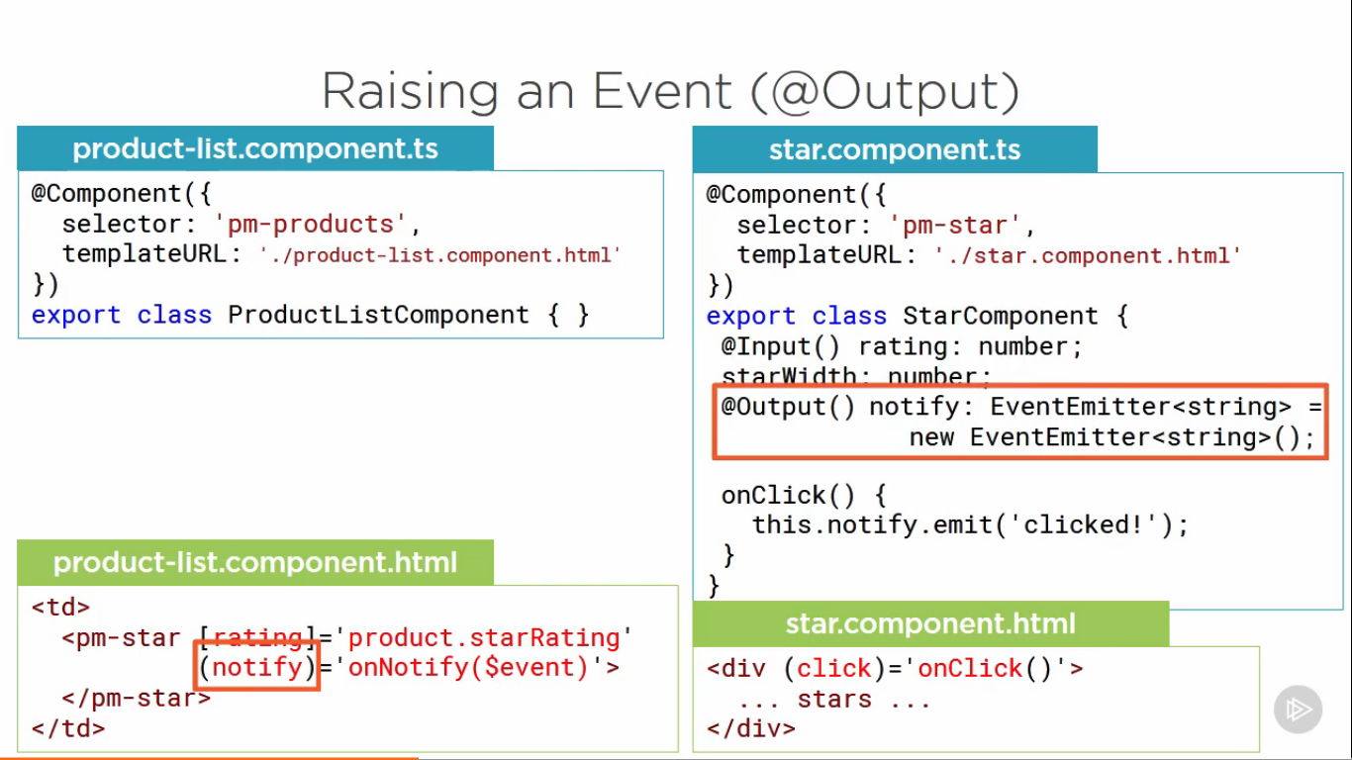

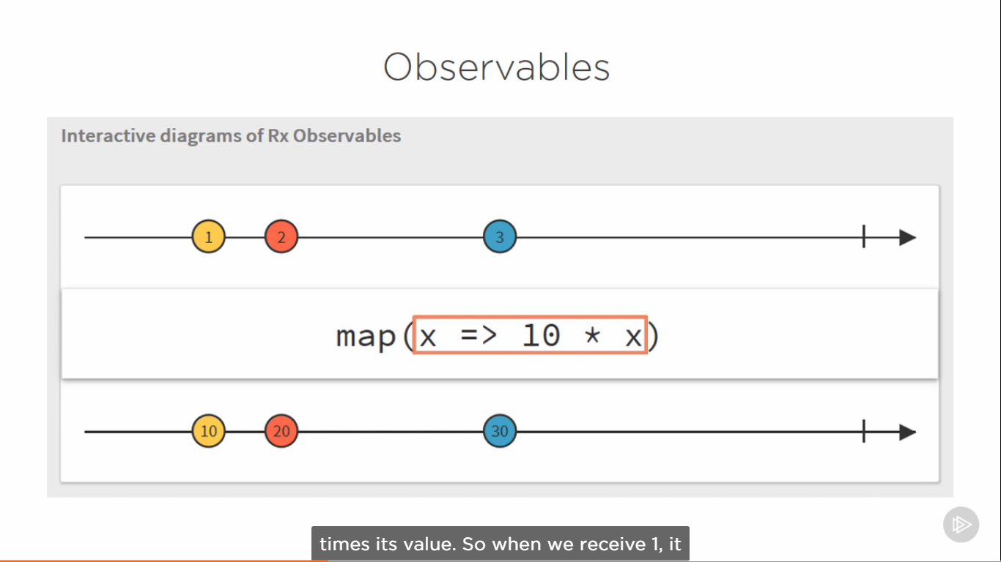

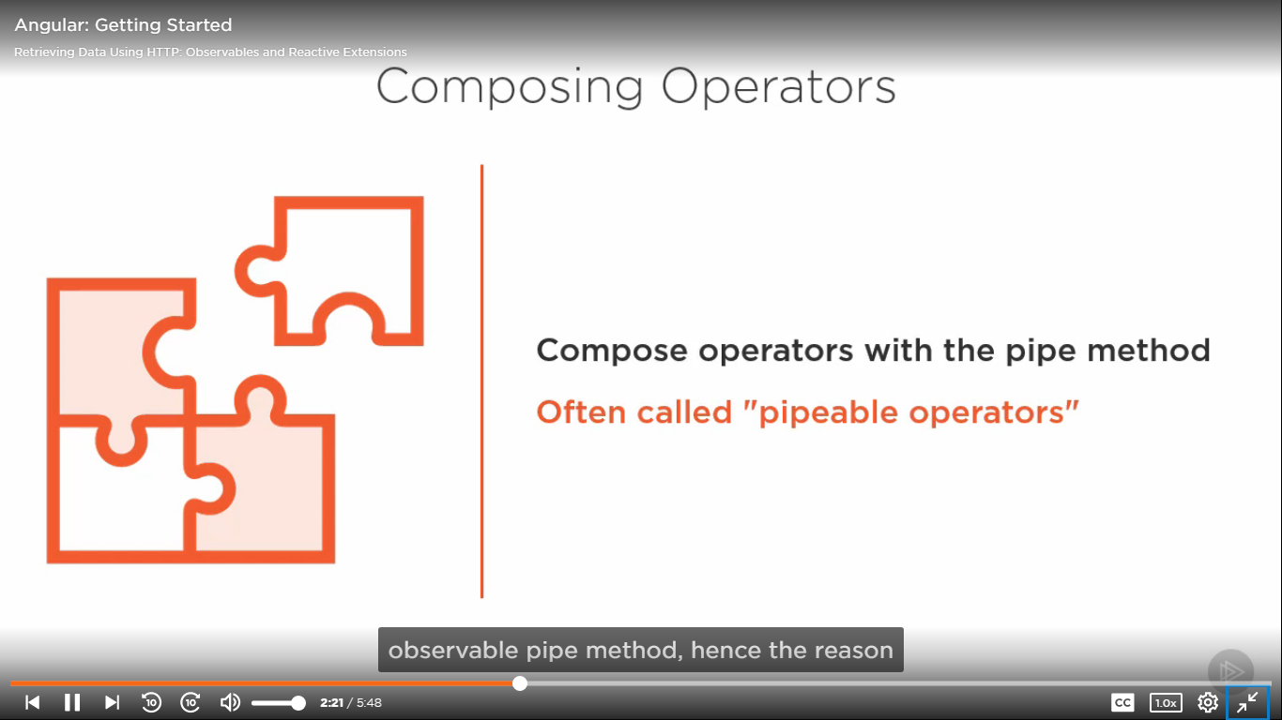

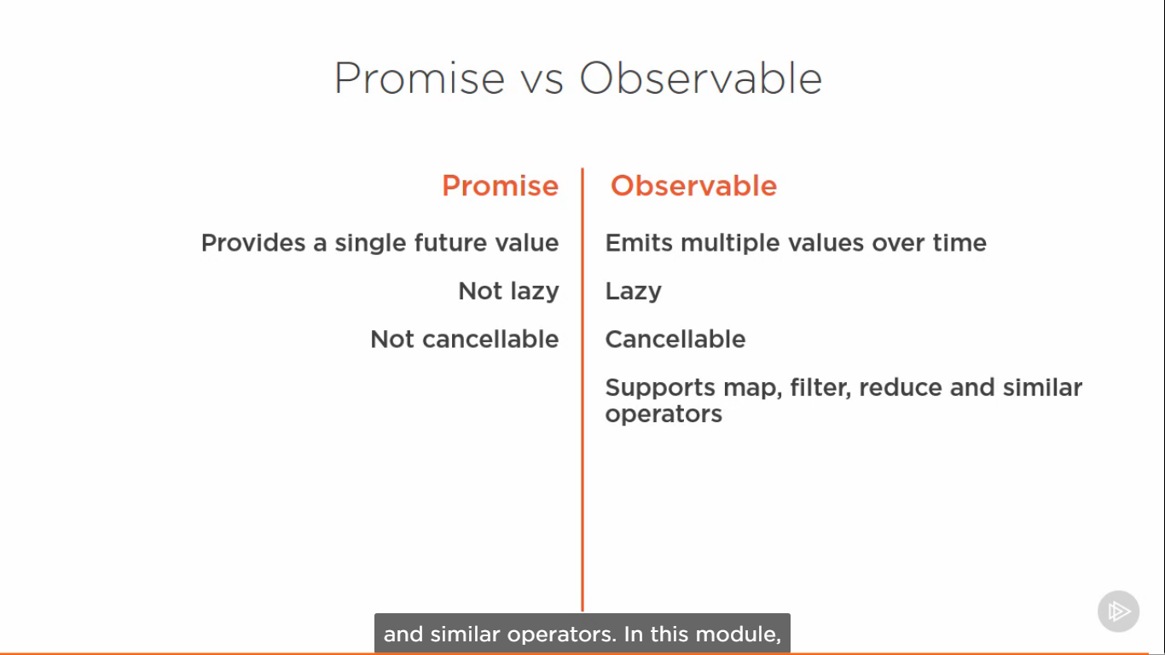

**Error handling in HTTP**

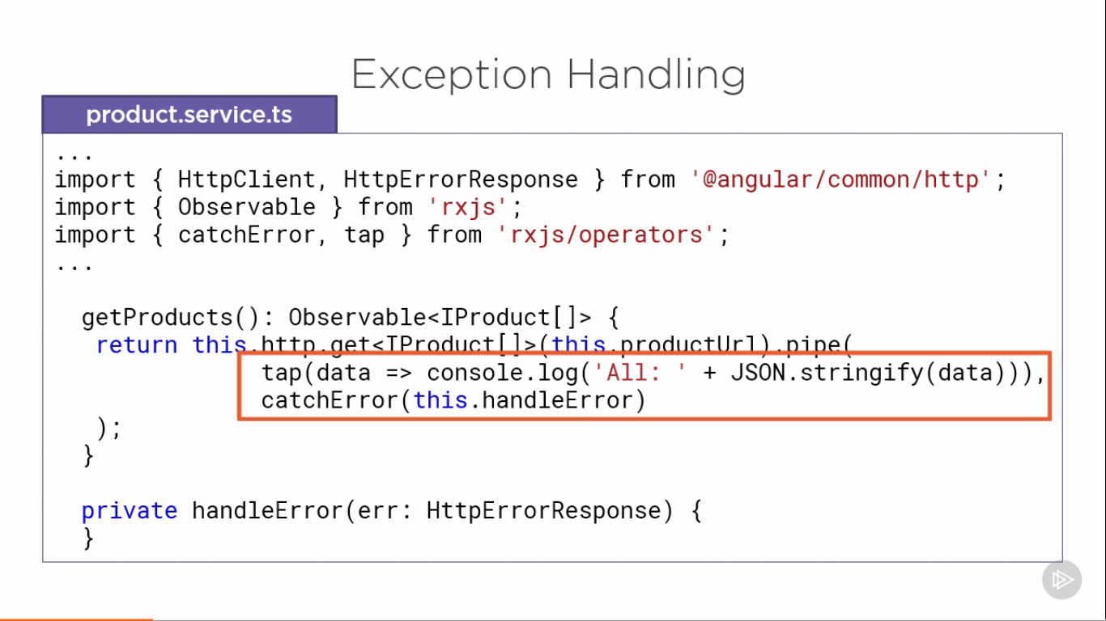

**Routing**

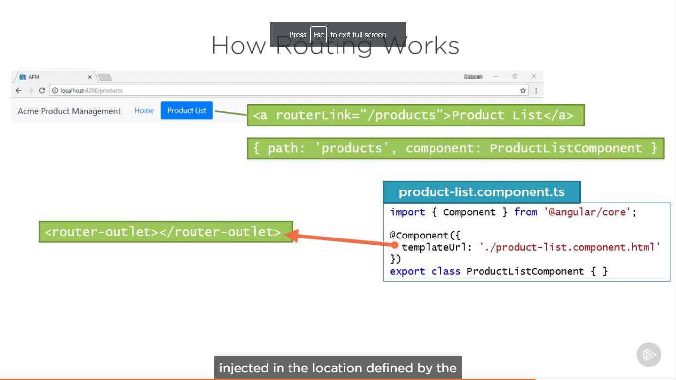

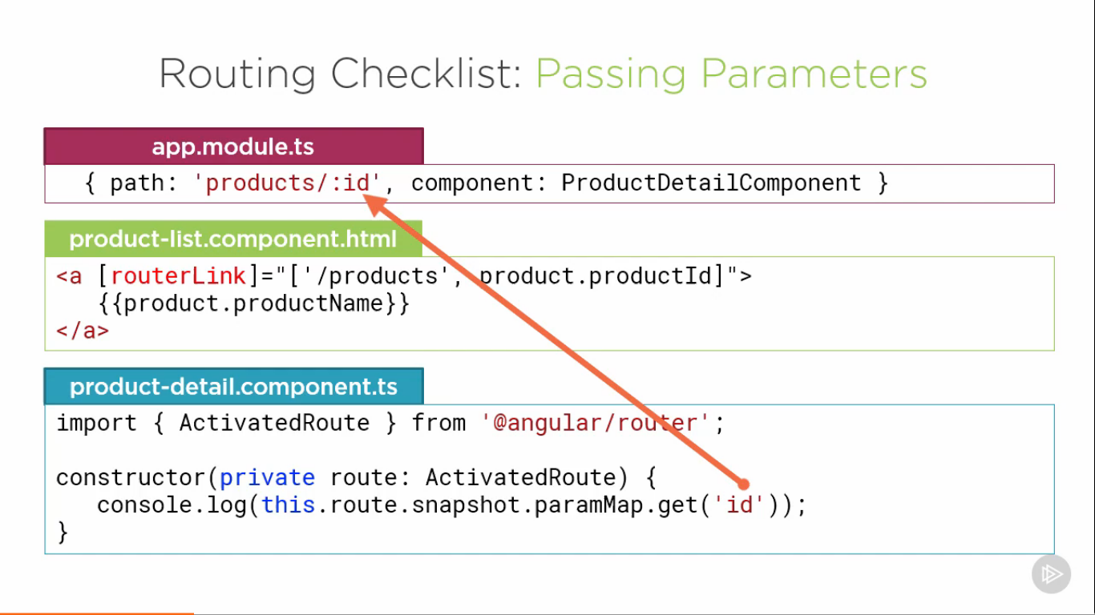

**Auth Guards**

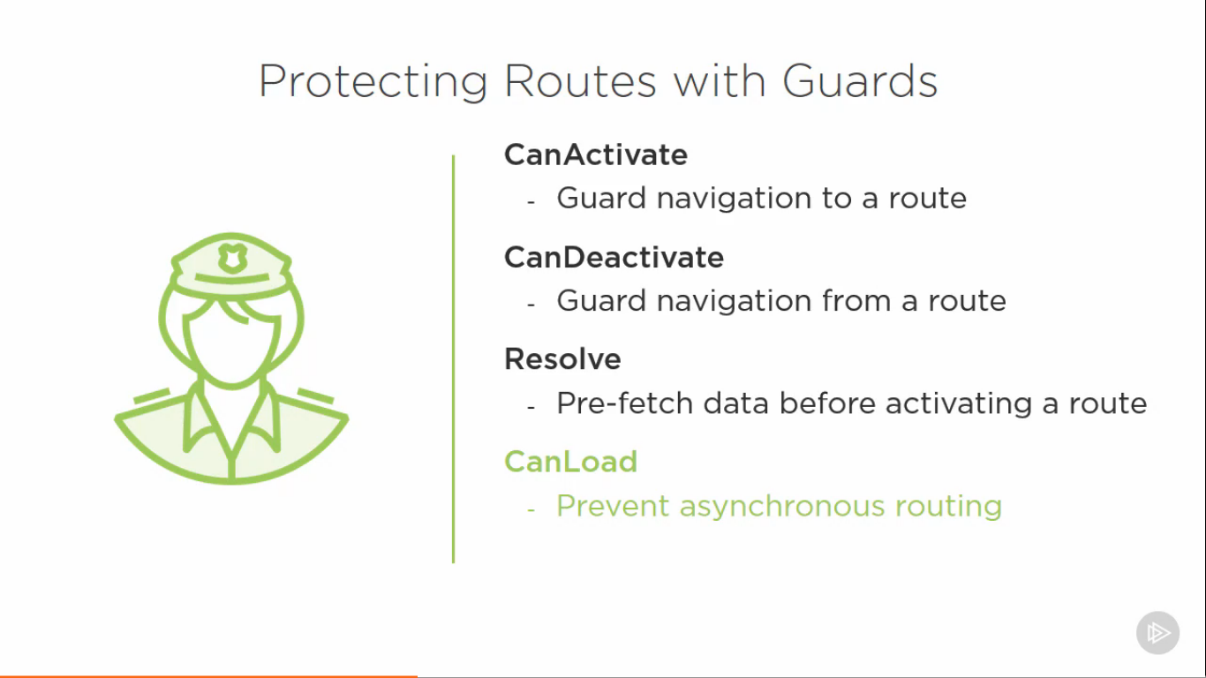

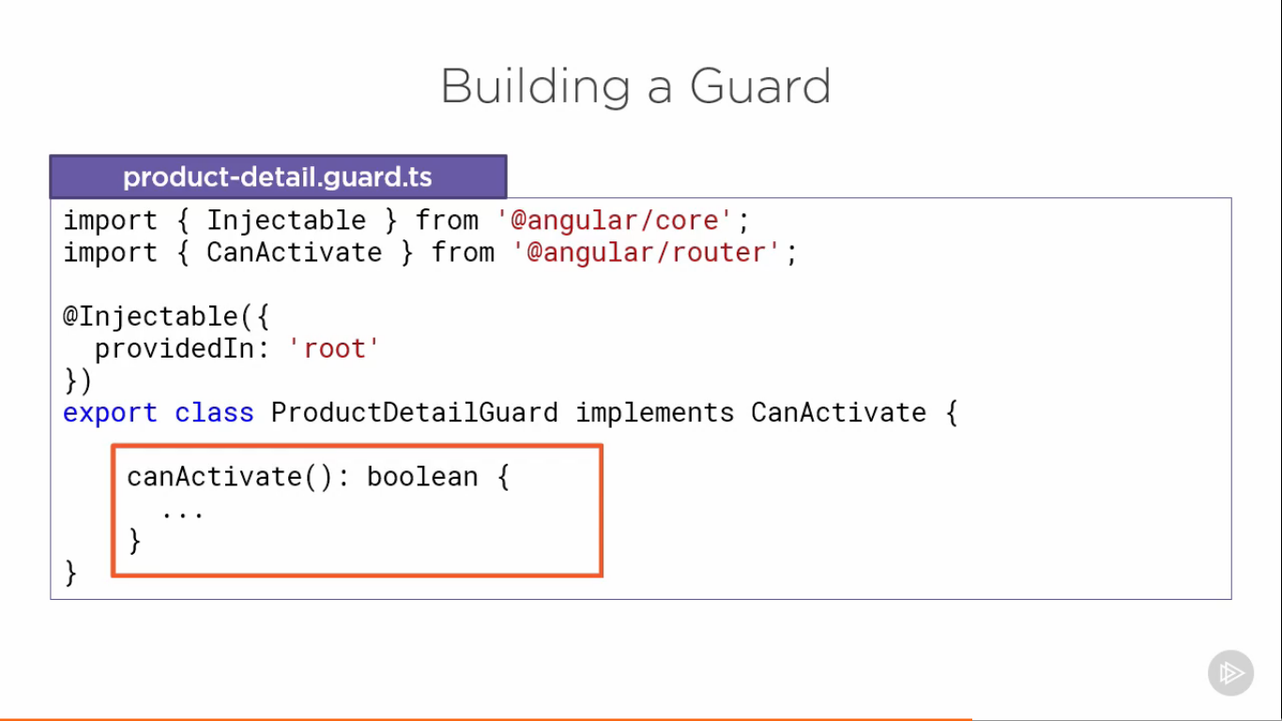

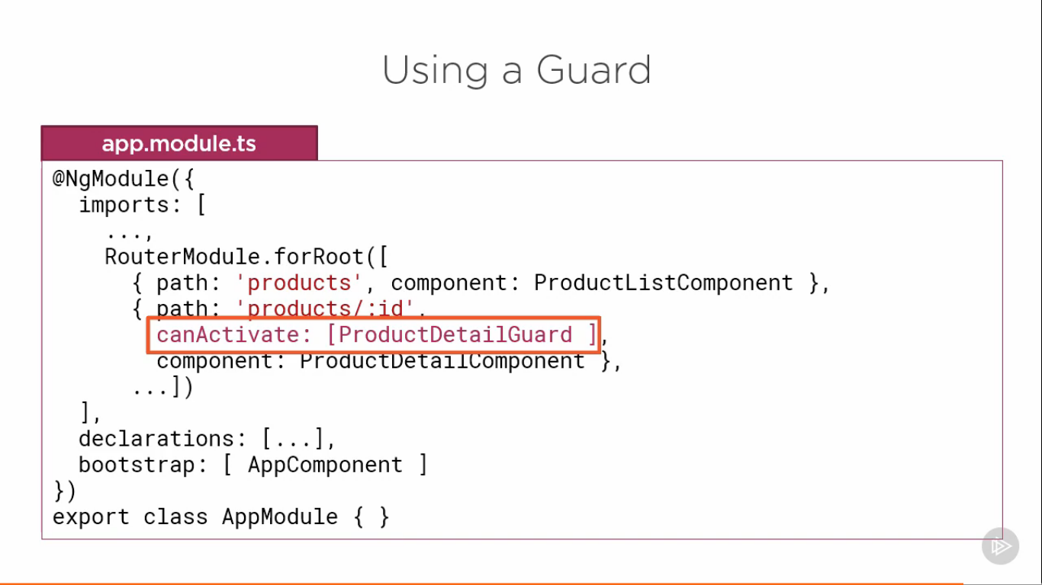

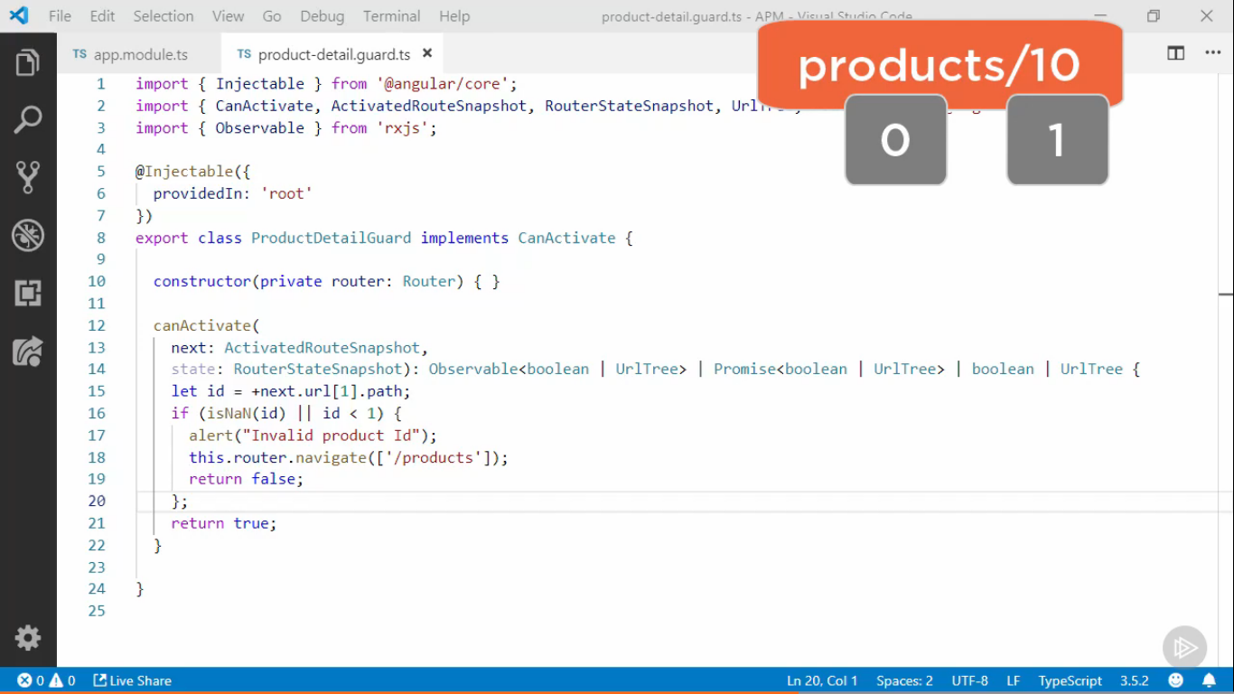

**MODULES**

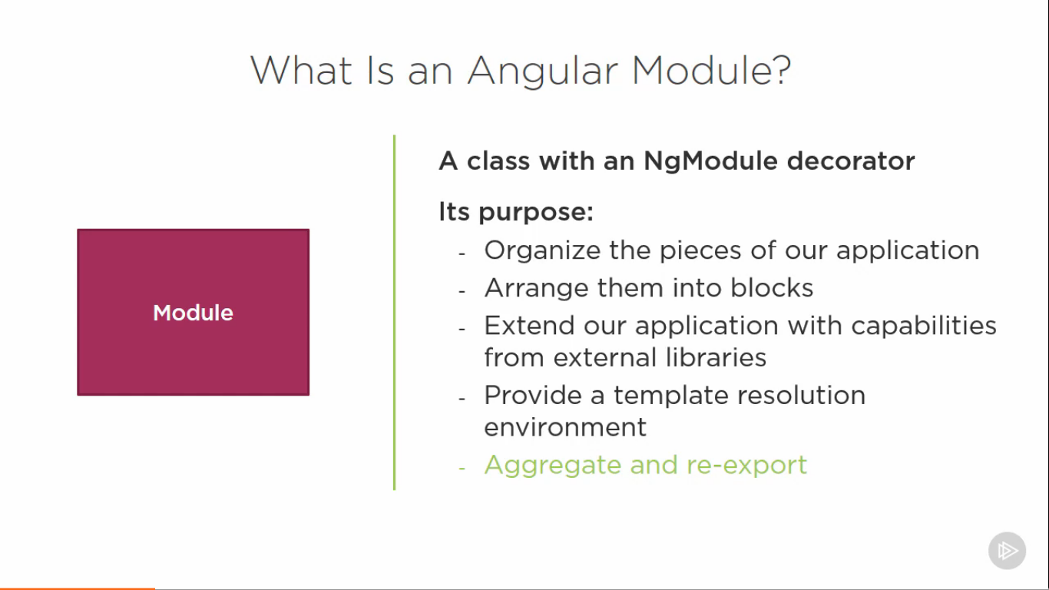

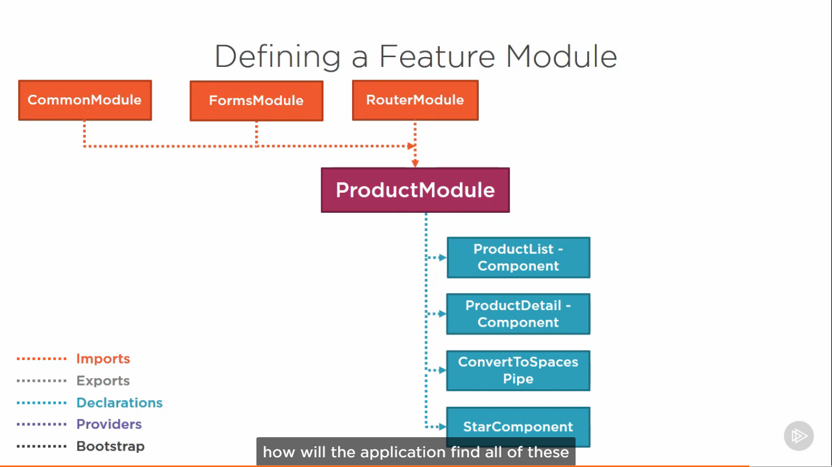

**For child is used so that the router instance is not created again (forRoot creates router instance)**

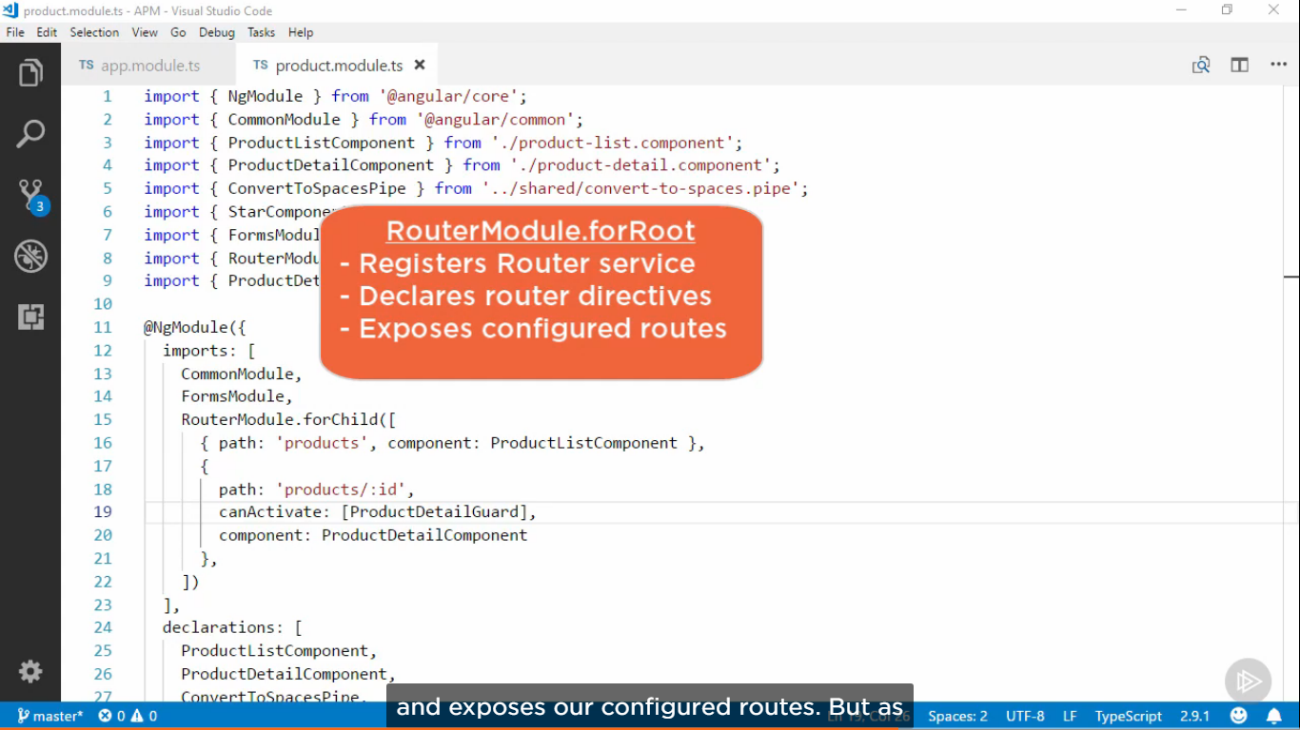

**CLI command for module creation and (-m) for importing it to another module.**

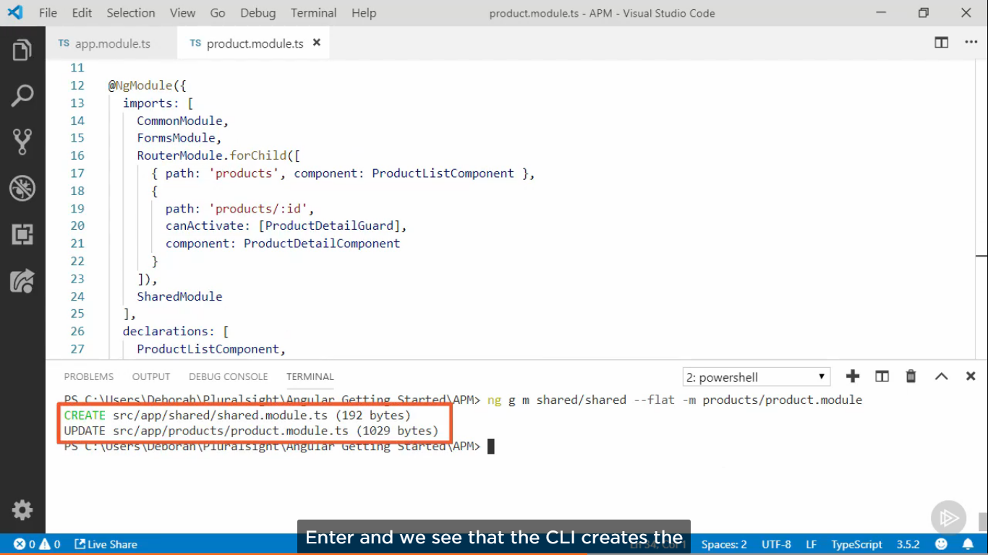

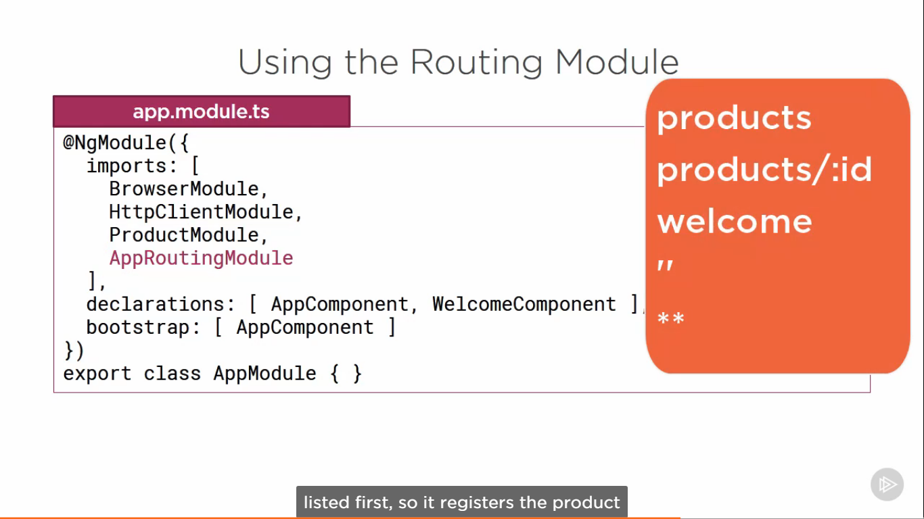

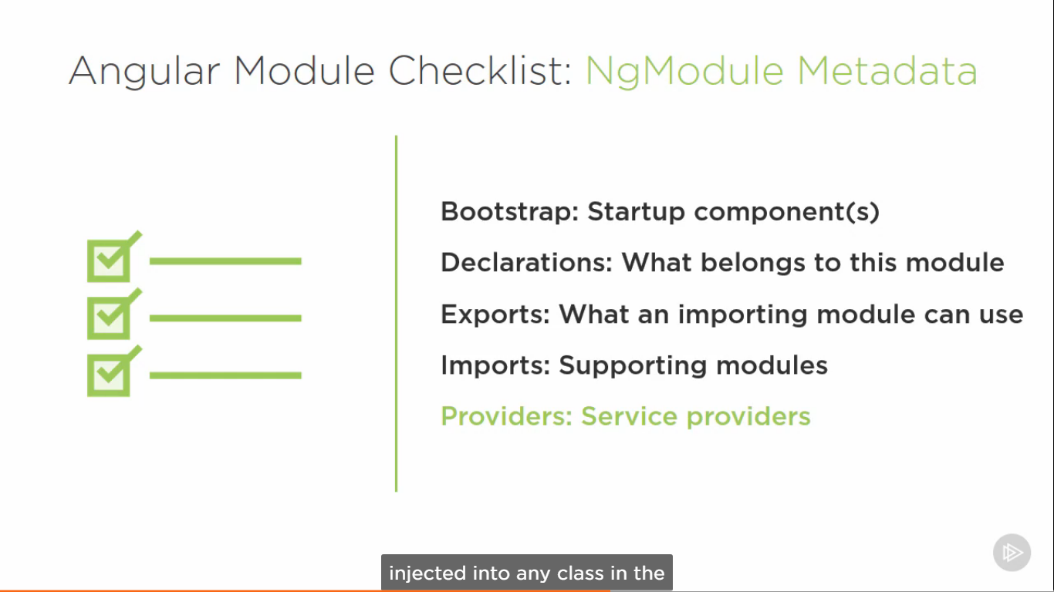

**Angular CLI**

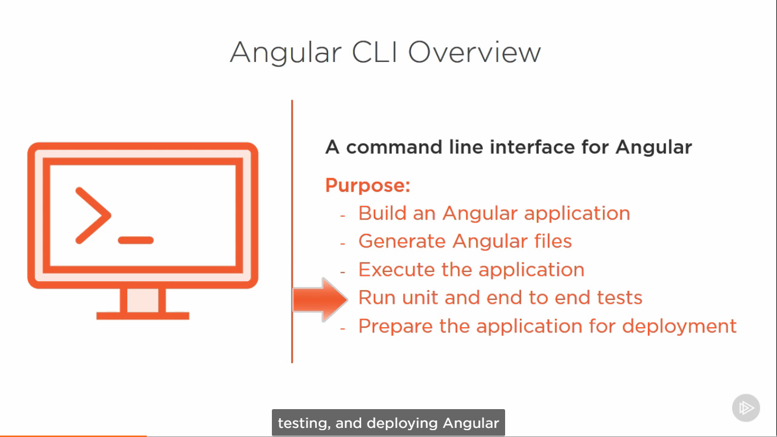

**Angular Folders Overview**

e2e – end to end test for the app

Node _ modules – contains the libraries installed by cli

src – source code of app.

App – modules, components, services

Assets – images, etc.

Environment – sets environment for build (prod is for production)

Index.html – the first file downloaded when a user access our application

Karma.config.js – sets up the karma, which is a javascript test runner used for unit tests

Main.ts – file that bootstraps our application

Polyfills.ts – supporting both evergreen and classic browsers

Test.ts – sets up for testing

Tsconfig for typescript configuration there are 2 versions one for compiling code another for compiling test specifications

Tslint.json – a typescript linter which checks our code against a set of code style rules and notifies us if any of the rules aren’t followed.

**Ng Build command (2 sets of file one is es2015 and other es5.js)**

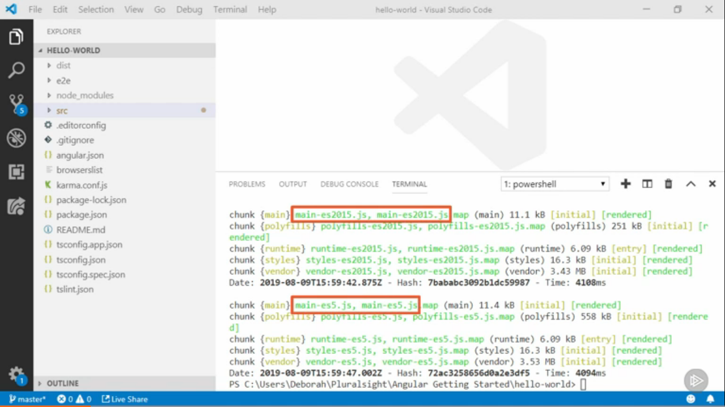

**Tree shaking (**Removing unused pieces**) AOT (**Precompile our templates)

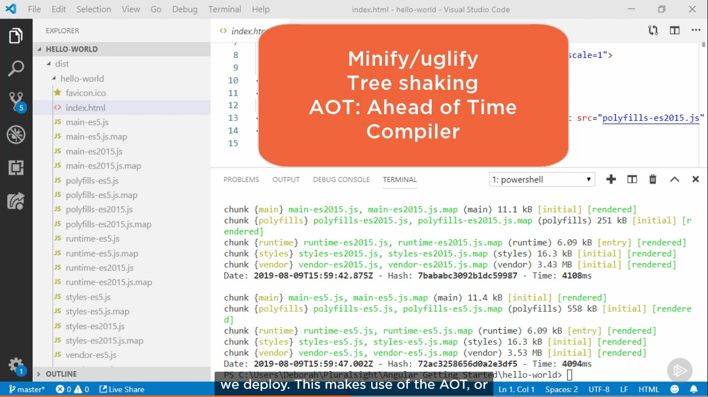

AOT- Instead of downloading the angular compiler as part of vendor bundles and running the compiler in the browser, we can make the bundles smaller and execute faster if we precompile before we deploy.

This can be done by cli command ng build –prod

Output-

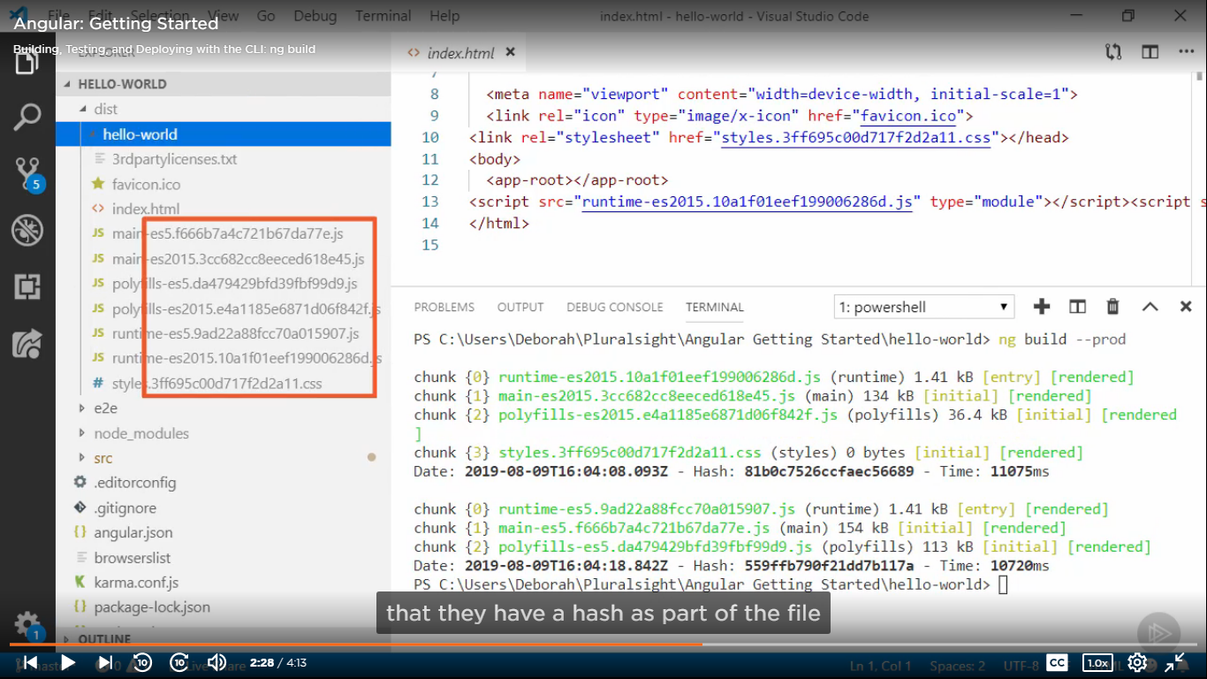

This is cache-busting technique

